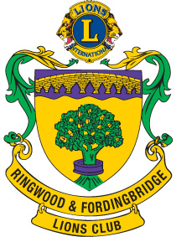
THE LIONS CLUB of SANDOWN & SHANKLIN Supported by
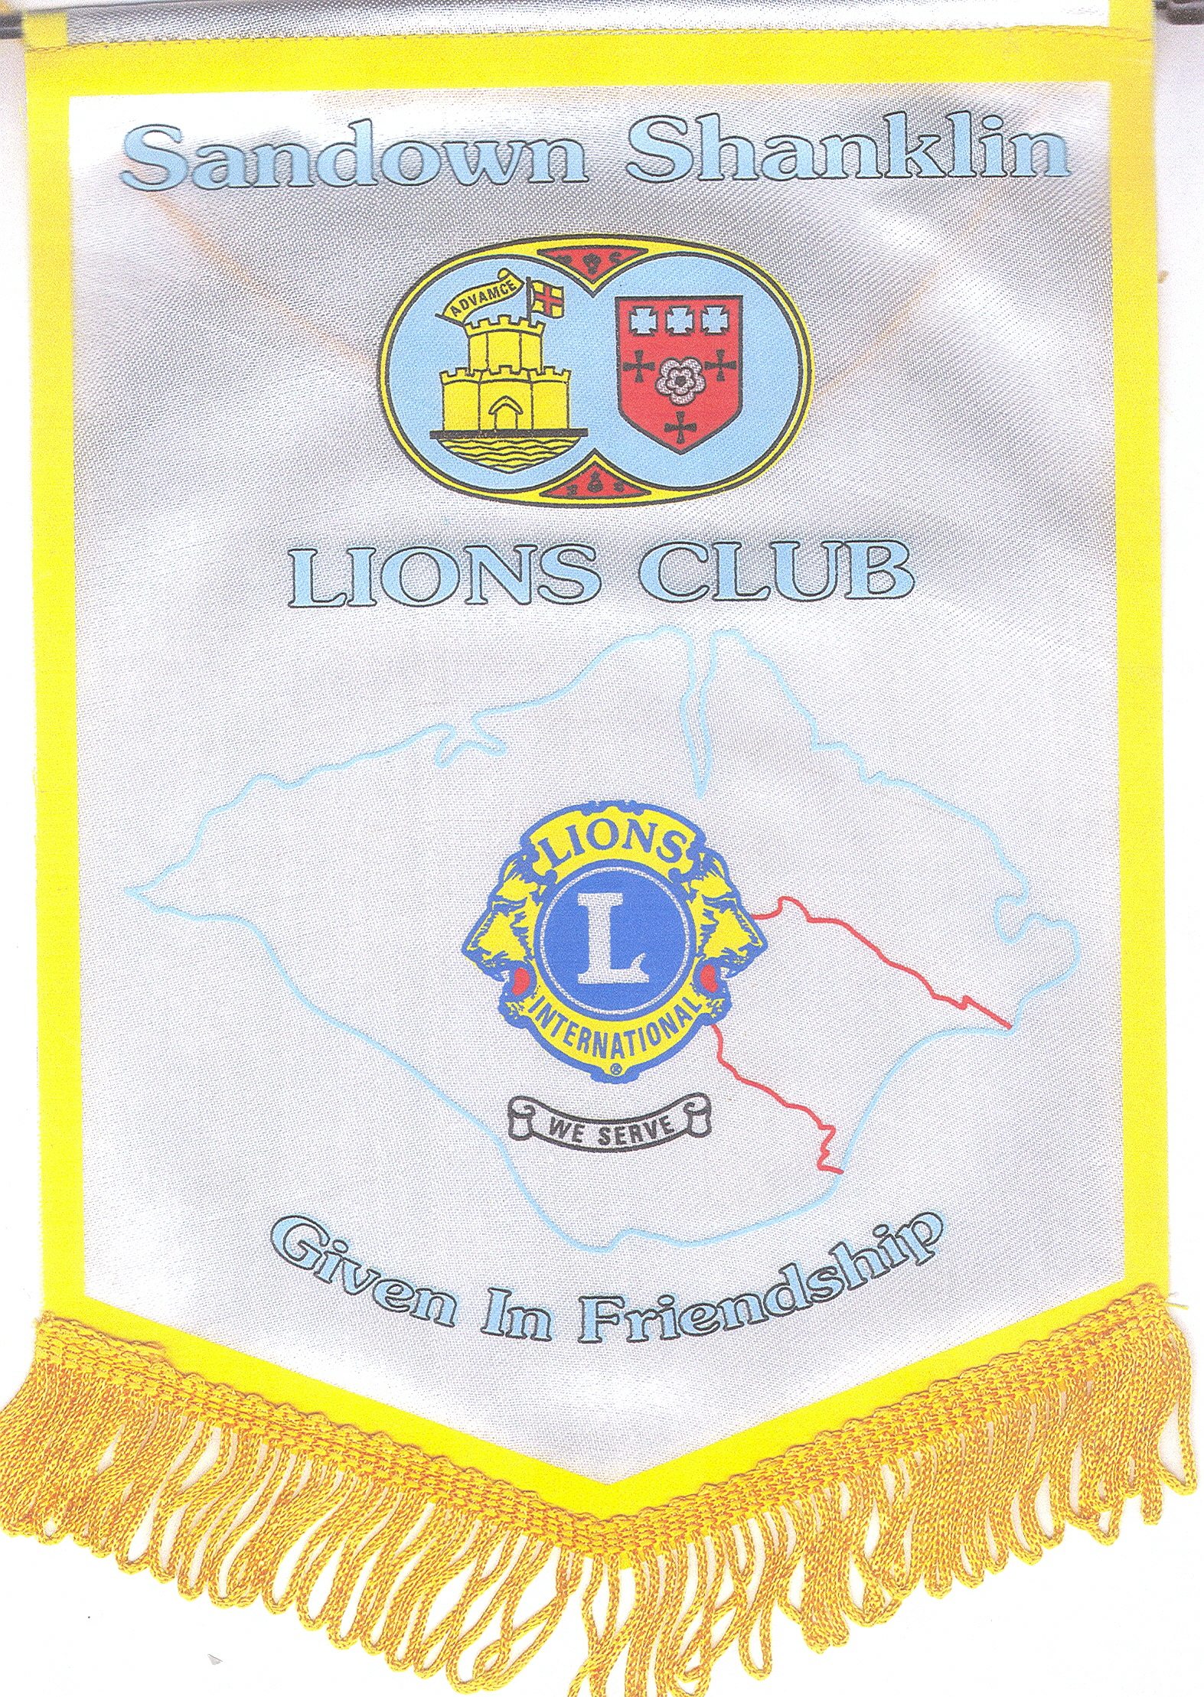
THE LIONS CLUB of RINGWOOD & FORDINGBRIDGE
Are proud to nominate
LION RON TWINING
For 1st Vice District Governor – District 105D
2010 – 2011
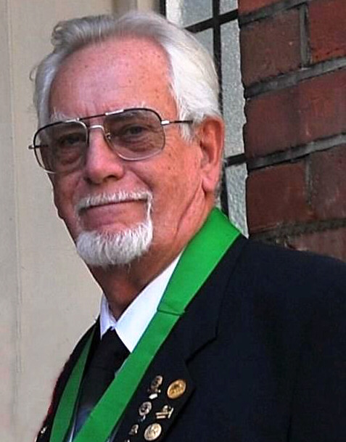
At Club Level:
Lion Ron joined as a Charter Member of Sandown and Shanklin in 1979. Since then he has been a 100% Lion serving the club at all levels, in various offices and as a Director and Chairman of all major committees. Over the years he has served as Vice President 83/84 93/94 98/99 08/09, as President 84/85, 94/95 99/00 & 09/10 and as Club Secretary from 1992 to 2001. He has served on the Convention Host Club Committee as Chairman 1983 to 1985, Secretary & Booking Treasurer 1991 to 1994 and on the Convention Host Zone Committee as Secretary and Vice Chairman for 4 other island based conventions and was the Host Zone Convention Chairman for the 2009 Convention.

At District Level:
Lion Ron joined the District Cabinet in 1996 as a Zone Chairman and has served on the Cabinet since then as Zone Chairman 96/97 97/98, Region Chairman 98/99, District Youth Exchange Officer 1999 to 2007, District Reports Officer 07/08 08/09, also CSF2 Zone Co-ordinator 06/07 07/08 08/09.He is currently the serving 2nd VDG for 2009/10.
He has recently qualified as a Certified Guiding Lion, and has attended presentation training, also in 2009 he attended and passed the Senior Lions Leadership course. He has also attended many other District training courses.

At Multiple District Level:
Lion Ron has served the MD as the Youth Exchange Coordinator inwards from 2003 to 2009, attending all the required training courses.
Although he was unable to attend on either occasion, Lion Ron was asked to make a presentation at the 2007 International Convention, in Chicago, on Youth Exchange, and also to chair the YEC meeting at Bangkok in 2008.

Attendance:
Lion Ron has attended the majority of district conventions, 7 MD conventions, 4 Europa forums, 6 international YEC conferences (co - chairing 3), including organising the one in England in 2006, and working for the week at the International Convention in Birmingham. He has also attended the majority of MD and district meetings as required.

Awards:
His club made Lion Ron a Melvin Jones Fellow in 1996 and he has also received the following awards: -
100% Presidents Excellence medals in 1995 and 2000, DG certificate of appreciation for service and cooperation in 1997 and 2009, International Presidents certificate of appreciation for membership 2004, 100% Secretary’s Excellence medal 2001, certificates of appreciation for service to the International Convention 1998 and similar for the Europa Forum 2006, a DG appreciation award medal 2006, the International Presidents award medal for services to youth 2007, and over the years has achieved 3 membership key awards.

At Work:
Lion Ron started his working life as an apprentice engineer and over the years has served in this trade as well as in sales and service, in supervisory and managerial positions, even owning his own Guest House for about 14 years. He is now retired from working part time in maintenance of a local private school.

Home & Family:
Lion Ron moved to the IoW in 1965 from Slough in Berkshire and is ably supported by his wife Lion Ann, who he met in 1987 and married in 1988. He also has one son aged 45 and a new grandson. Apart from his Lions activities, at age 55+ he took and passed 7 O level and 3 A level exams, to add to all his earlier qualifications. Also in the past he has spent many years working with the scouts, carnival and various other local charities and town committees, including being a local and County Councillor. In fact since leaving school he has spent most of his free time serving his community.

